**Year 12 ATAR Human Biology Unit 3**

**Assessment Task 2**

**Science Inquiry (practical): Reflexes, reactions & reflex arcs – 5 marks**

**Part A – Reflexes: 3 marks**

Your nervous system coordinates your reflex actions in which responses occur extremely rapidly. Little time is lost because conscious decisions are not involved in responding.

**Materials:**

* Eye mask or blind fold
* Medical rubber mallet
* Small torch
* Piece of cardboard (10cm x 10cm)

**Pupillary reflex (2 marks)**

1. One person is to cover their eyes with the eye mask or blind fold. After two minutes, remove the mask and note the diameter of the pupils of your subject’s eyes.

a. Describe what happens to the pupil size when the mask is removed.

b. Why did you need to have the mask or blind fold on for 2 minutes before recording pupil size?

2. Darken the room and get your subject to hold a piece of cardboard along their nose in the midsagittal plane. Shine a torch light in one eye only.

a. What happened to the pupil size in both eyes?

**Patellar reflex (1 mark)**

3. Sit the subject on a chair with one leg crossed over the other so that the foot is hanging freely. Sitting on a high bench would work too. Find their patella and the tendon just below it.

**Gently** strike the patellar tendon with the rubber hammer.

a. What response did this cause?

b. Can the subject stop the reflex action?

**Part B – Reaction times: 2 marks**

**Purpose:** To investigate reaction times of young adults and to appreciate that reaction times can change due to environmental influences.

**Materials:**

* 30cm ruler

**Procedure:**

1. Person A sits comfortably with their right forearm on a table with their hand over the edge.

2. Hold out the hand forming a 4cm gap between the thumb and forefinger.

3. Person B holds a 30cm ruler between the thumb and forefinger. The thumb should be in line with the zero mark.

4. Person B drops the ruler.

5. Person A tries to catch the ruler as quickly as possible between the thumb and forefinger.

6. Record the distance shown just above the thumb on the ruler.

7. Repeat steps 1-6 four more times and calculate the average.

8. Repeat steps 1-7 with Person A’s left hand.

9. Repeat steps 1-8 with Person A counting backwards by 3s from 100.

**Results:**

|  |  |  |  |  |  |  |
| --- | --- | --- | --- | --- | --- | --- |
| Right hand | Distance ruler dropped before being caught | | | | | |
|  | Trial 1 | Trial 2 | Trial 3 | Trial 4 | Trial 5 | Average |
| Person A |  |  |  |  |  |  |
| Person A Counting |  |  |  |  |  |  |

|  |  |  |  |  |  |  |
| --- | --- | --- | --- | --- | --- | --- |
| Left hand | Distance ruler dropped before being caught | | | | | |
|  | Trial 1 | Trial 2 | Trial 3 | Trial 4 | Trial 5 | Average |
| Person A |  |  |  |  |  |  |
| Person A Counting |  |  |  |  |  |  |

a. How can reaction time be judged from the distance dropped by the ruler?

b. From these results, can you tell if someone is right or left handed? Explain.

**Year 12 ATAR Human Biology Unit 3**

**Assessment Task 2**

**Science Inquiry (practical): Reflexes, reactions & reflex arcs**

**Validation Test (25 marks)**

1. The pupillary light reflex suggests that the reflex arcs of both eyes are connected. Explain a possible advantage of this arrangement. [1]

2. What is the importance of the pupillary light reflex? [2]

3. On Figure 1 below, label the following parts: [6]

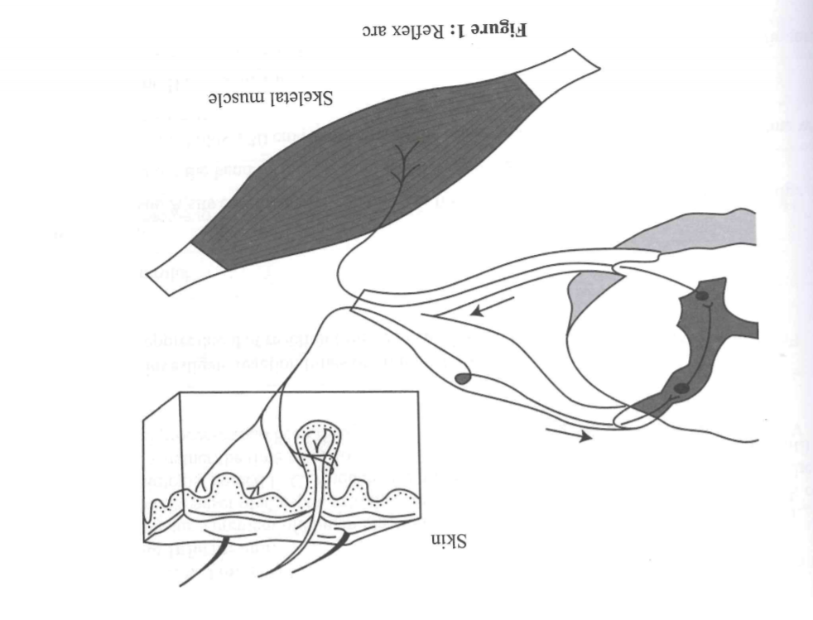a) motor neuron

b) cell body of motor neuron

c) sensory neuron

d) cell body of sensory neuron

e) connector neuron

f) dorsal root

g) dorsal root ganglion

h) ventral root

i) receptors

j) grey matter of spinal cord

k) white matter of spinal cord

l) afferent and efferent pathways

Figure 1: Reflex Arc (Exploring Human Biological Science Stage 3: Changing Bodies p. 181)

4. What are the characteristics of a reflex? [3]

5. With reference to the Figure 1 on the previous page, describe the steps of a spinal reflex. [5]

6. Explain how spinal reflexes contribute to the maintenance of homeostasis in the body. [2]

7. Explain why a test subject would usually have a faster reaction time when catching the ruler with their dominant hand. [3]

8. Comment on the validity and reliability of the results you collected in the ruler drop activity. [3]